Abstract submission – Shipping and the Environment 2019

Title:

Authors:

Corresponding author:

E-mail of corresponding author:

Preferred session:

Is the preferred mode of presentation an oral presentation? [y/n]:

Additional comments:
Instructions for abstract preparation for Shipping and the Environment

A.B. First¹, C.D. Second² and E.F. Third²

¹Department, Institute/University, Place, Zip Code, City, Country
²Department, Institute/University, Place, Zip Code, City, Country

Keywords: first, second, third, fourth

Introduction
The abstract should be camera-ready and in double column (like this EXAMPLE), and ONE page long. Use A4 page set-up and make all margins (top, bottom, left, right) 25 mm wide. Start typing text here (about 7cm from the top of the page). Use 10 pt Times New Roman font (except for the title which should be in 12 pt bold and in lower case). Centre the title, the authors’ names, the addresses, and keywords. You can include up to four keywords. For the body of the abstract, start each paragraph with a tab, and use tab settings of 1 cm. Justify the body of the text both left and right.
Methods
Figures and Tables may be included in the abstract, but make sure that they have a caption, and that they are numbered consecutively using Arabic numerals. The font used in captions should be 10 pt. Vertical lines in tables should be avoided.

Table 1. Properties of ships in the study.
Ship | Gross tonnage | Average speed (knots)
S1  S2  S3  S4 | 18 524  20 568  46 215  44 201 | 13.5  13.0  17.5  17.7
S5 | 22 983 | 15.2

References should be made in the style (Colls, 2002), or (Hamerly & Elkan, 2003; Ciambelli et al., 1998) or simply refer to Ciambelli et al. (1996). Examples of references are shown below. Leave a blank line above the list with references (and also above the acknowledgements).
Conclusions
Authors are invited to submit a one page abstract. The authors are also asked to facilitate the abstract review process by classifying their contribution according to one of the following sessions:
- Symposium on Scenarios and Policy Options for Sustainable Shipping (POL)
- Emissions and abatement measures (EAM)
- Atmospheric processes (ATM)
- Marine processes (MAR)
- Noise (NOISE)
- Poster session (POS)
(for details go https://s-and-e-2019.ivl.se). The abstracts will be reviewed by the convenors for the chosen session according to scientific content, suitability for the conference and form. Abstracts which do not fulfil the standards will be rejected. Please, avoid submitting abstracts containing only future results.
Please submit your abstract in camera-ready form according to the guidelines given here. The abstract should be submitted as WORD or PDF format on the conference website https://s-and-e-2019.ivl.se. Please remember to fill in the form on the first page on this document.
The deadline for abstract submission is 17th of May 2019.

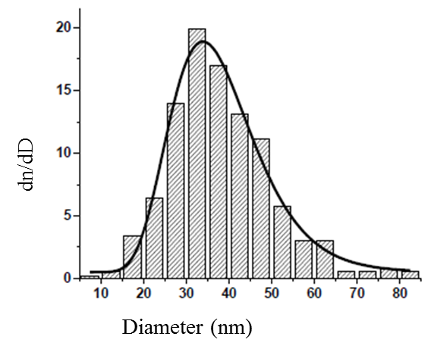
Figure 1. Size distribution of primary soot-type particle and its lognormal fit.

Authors should acknowledge any person, or funding agency that has made a significant contribution to the work. The abstract template is adopted from the NOSA Aerosol Symposium 2017.

Ciambelli, P., Corbo, P., Gambino, M., Palma, V., & Vaccaro, S. (1996). Catal. Today, 27, 99-106.
Colls, J. (2002). Air Pollution (second ed.). London, UK: Spoon Press.
Hamerly, G., & Elkan, C. (2003). in Proceedings of 17th Annual Conference on Neural Information Processing System (NIPS), 16, 281-288.

